**Glassdoor Salary Analysis**

## Cleaning and Transformation:

* Add column for people working per hour.
* Clean estimated_salary column.
* Transform estimated_salary from 17$ −24$ Per Hour (Glassdoor est.) to 17$ −24$ Per Hour | 53K-91K (Glassdoor est.) to 53K-91K.
* Split estimated_salary to 2 columns (53K) and (91K): Min Annual Salary and Max Annual Salary.
* Multiply hourly salary by 12*40*4.
* Remove ‘K’ character and multiply by 1000.
* Get the average of salaries in Average Annual Salary column.
* Replace -1 rate with 0 indicating bad rate.
* Remove rate from Company Name.
* Drop Job 741 as it is dirty and misleading.
* The founded date has missing values represented by -1.
* Calculate the age of the company with -1 representing the missing data.
* Create Age Classification with 50 years range for each section.
* The type of ownership has missing values represented by unknown.
* The size has missing values represented by unknown.
* The industry has missing values represented by unknown.
* The sector has missing values represented by unknown.
* Classify Company size Ascending from A to G.
* Classify Revenue Ascending from 1 to 12.
* Join The 2 datasets to get skills columns.
* Duplicate glassdoor_jobs table.
* Unpivoting skills columns.
* Delete Unnecessary and unused columns.

## Challenges

* + When I started to think about data, I found that the main parameter that I interested in is: **Salary**
  + I think about a lot of other insights, but it wasn’t related to salary, so I ignored it.
  + I build 3 pages in my dashboard, I tried to put charts with same type in the same page.
  + 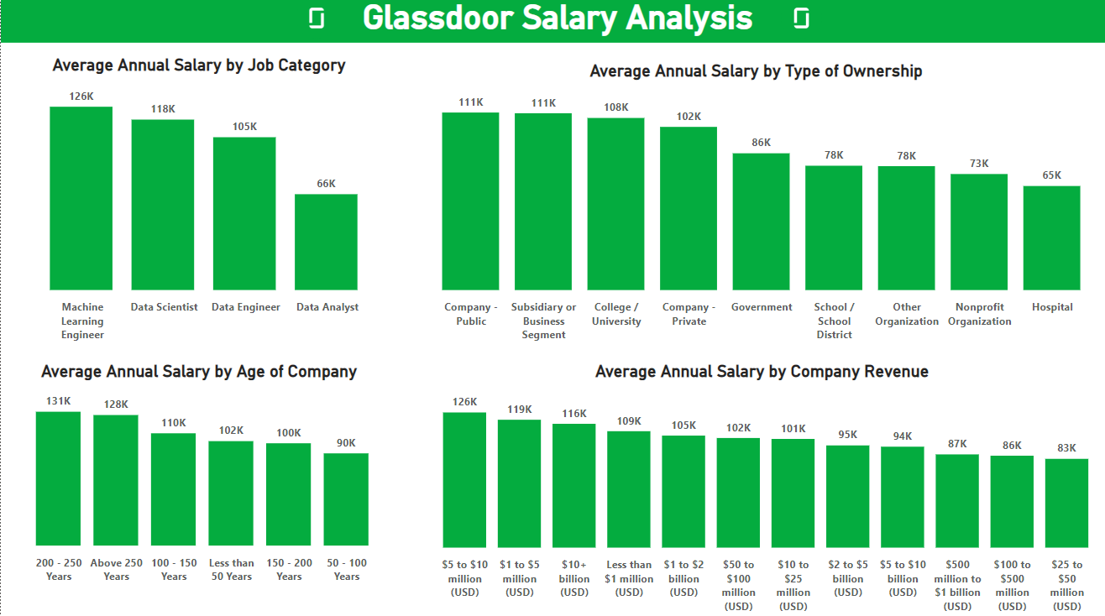I needed to make a lot of changes and add columns like classifications of other columns to my data to be able to visualize data as below:

